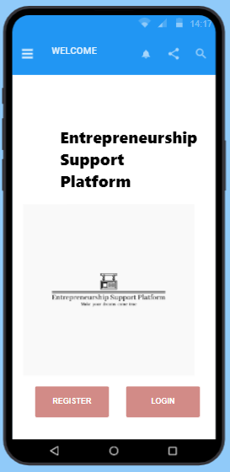

The welcome page has the registration and the login button,

When the user clicks on the register button, they will be redirected to the registration window for authentication, new users’ need to provide with fist name, last name, email, and password, then confirm their password. **Optionally**, users have an option to register using their Facebook, Instagram and google accounts. If the users want to save their password so they that they will not need to provide it again next time logging in, they can check the “save password”. Then finally click on the register button so that the information can reflect/save into the database.

Once the user is authenticated, they will be authorised, when the user clicks on the login button from the welcome page, they will be prompt for their email and password so that they can gain access to the platform.